MET CS 555 Assignment 3
Joseph Rissman
11/03/2024
- To get a sense of the data, generate a scatterplot (using an appropriate window, label the axes, and title the graph). Consciously decide which variable should be on the x-axis and which should be on the y-axis. Using the scatterplot, describe the form, direction, and strength of the association between the variables.
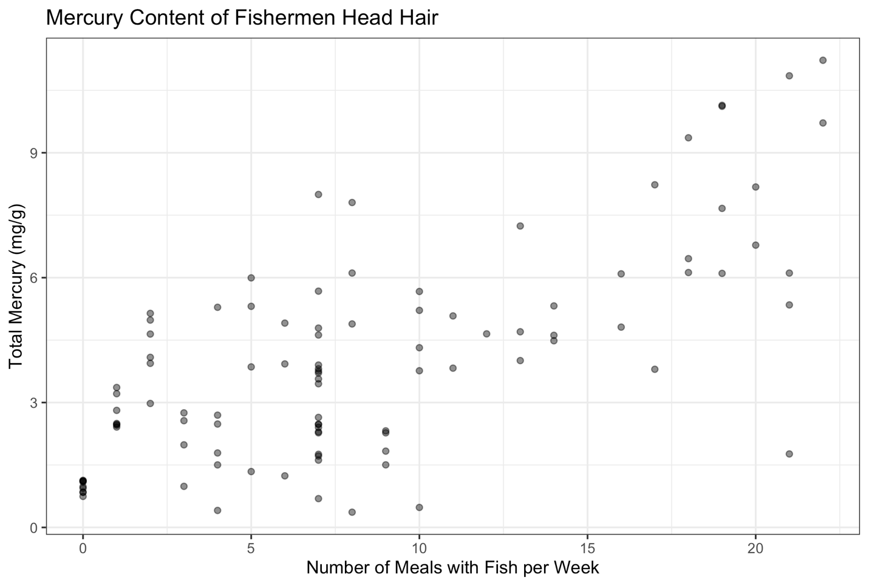
The variables appear to be linearly, positively, and moderately associated.
- Calculate the correlation coefficient. What does the correlation tell us?
The correlation coefficient of the two variables is 0.6991094. This tells us that the variables are moderately positively associated.
- Find the equation of the least squares regression equation and write out the equation. Add the regression line to the scatterplot you generated above.
Using R, least squares regression equation is calculated to be:
$$\hat{y}=1.68764+0.27595x$$
Where $\hat{y}$ is the total mercury in mg/g and $x$ is the number of meals per week with fish.
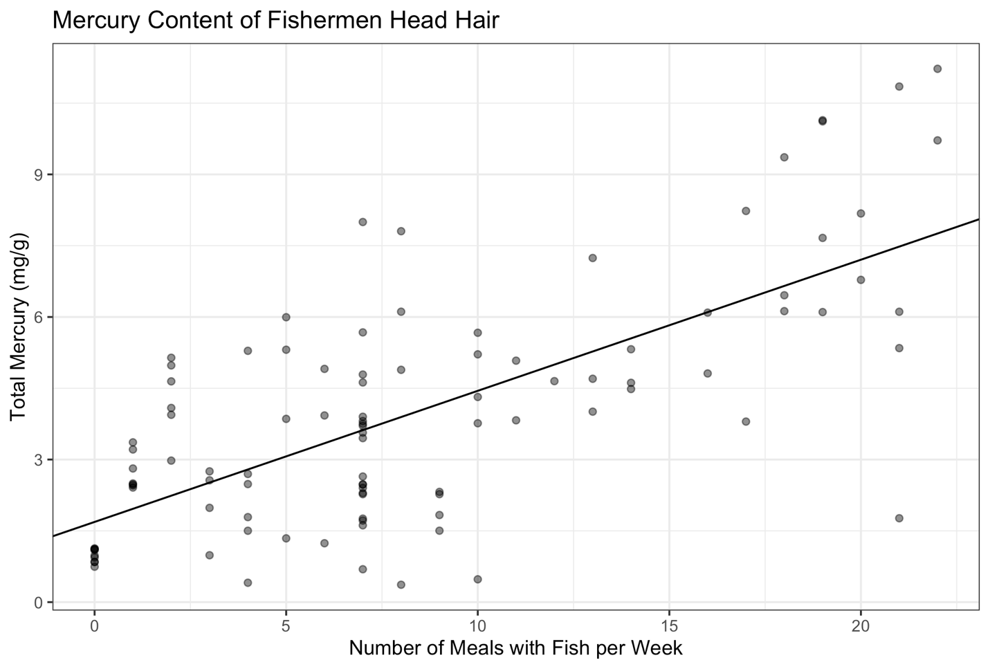
- What is the estimate for $β_{1}$? How can we interpret this value? What is the estimate for $β_{0}$? What is the interpretation of this value? For the interpretations, you should be interpreting them in the context of this specific data set.
The estimate for $β_{1}=0.27595$. This value means that for an increase of 1 meal per week containing fish, the total mercury in head hair increases by 0.27595 mg/g.
The estimate for $β_{0}=1.68764$. This value means that fishermen that have 0 meals per week with fish, the total mercury in head hair is 1.68764 mg/g.
- Calculate the ANOVA table AND the table which gives the standard error of $\hat{β_{1}}$. Formally test the hypothesis that $β_{1}=0$ using either the F-test or the t-test at the 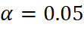$α=0.05$ level. Either way, present your results using the 5-step procedure, as described in the course notes.
Within your conclusion, calculate the R-squared value and interpret this. Also, calculate (using R) and interpret the 90% confidence interval for $β_{1}$.
Coefficient | Estimate | Standard Error
$$\hat{β_{0}}$$ | 1.68764 | 0.29833
$$\hat{β_{1}}$$ | 0.27595 | 0.02851
Using the F-test for Simple Linear Regression.
- Set up the hypotheses and select the alpha level.
$H_{0}:β_{1}=0$ (there is no linear association)
$H_{1}:β_{1}≠0$ (there is a linear association)
$$α=0.05$$
- Select the appropriate test statistic.
$$F=\frac{\text{MS Reg}}{\text{MS Res}}$$
$$df_{reg}=k=1$$
$$df_{res}=n-k-1=98$$
- State the decision rule.
F-distribution with 1, 98 degrees of freedom and associated with $α =0.05$.
$$F_{1,98,0.05}=3.938111$$
Decision Rule: Reject $H_{0}$ if $F≥3.93811$
Otherwise, do not reject $H_{0}$
- Compute the test statistic.
 | SS (Sum of Squares) | df (degrees of freedom) | MS (Mean Square) | F-statistic | p-value
Regression | 309.24 | 1 | 309.239 | 93.689 | $$6.013×{10}^{-16}$$
Residual | 323.47 | 98 | 3.301
Total | 632.71
$F=\frac{\text{MS Reg}}{\text{MS Res}}=\frac{309.239}{3.301}=93.689$ with 1 and 98 degrees of freedom.
- Conclusion.
Reject $H_{0}$ since $93.689≥3.93811$.
We have significant evidence at the $α=0.05$ level that $β_{1}≠0$.
There is evidence of a significant linear association between mercury in head hair and number of meals per week with fish (here, p<0.001 as calculated using R).

$$R^{2}=\frac{\text{Reg SS}}{\text{Total SS}}=\frac{309.24}{632.71}=0.4888$$
The $R^{2}$ value means that 48.88% of the variability in mercury in head hair in mg/g can be explained by the number of meals per week with fish.

90% confidence interval of $β_{1}$ is (0.228609, 0.3232916). The value means that we are 90% confident that the true value of the slope lies between 0.228609 mg/g mercury per meal with fish per week and 0.3232916 mg/g mercury per meal with fish per week.

R code for Assignment 3
# CS555 Homework Assignment 3
# Load necessary libraries ------------------------------------------------
library(readxl)
library(dplyr)
library(tidyr)
library(ggplot2)

# Import and clean data ---------------------------------------------------
# Read experiment data from Excel file
data <- read_excel("Homework 3/Homework 3 Data.xlsx", col_names = TRUE)
names(data) <- c("Meals","Mercury")

# Problem 1 ---------------------------------------------------------------
# Generate a scatterplot
gg <- ggplot(data, aes(x = Meals, y = Mercury)) +
geom_point(alpha = 0.5) +
labs(
x = "Number of Meals with Fish per Week",
y = "Total Mercury (mg/g)",
title = "Mercury Content of Fishermen Head Hair "
) +
theme_bw()
plot(gg)
ggsave("Homework 3/scatter.png")

# Problem 2 ---------------------------------------------------------------

# Calculate the correlation coefficient.
cor(data)

# Problem 3 ---------------------------------------------------------------

# Find the equation of the least squares regression equation.
model <- lm(Mercury ~ Meals, data)
coefficients <- coef(model)
coefficients

# Add the regression line to the scatterplot.
gg <- gg + geom_abline(
intercept = coefficients[1],
slope = coefficients[2]
)
plot(gg)
ggsave("Homework 3/regression.png")

# Problem 4 ---------------------------------------------------------------

# Calculate the estimates for B0 and B1
summary(model)

# Problem 5 ---------------------------------------------------------------

# Calculate the ANOVA table.
anova(model)

# Calculate the 90% confidence interval for B1
confint(model, "Meals", level = 0.9)

